DIGITAL INDUSTRIAL PRODUCTS

E- 62, SECTOR – 9. NOIDA 201301(U.P.)

An ISO 9001:2008 Certified Company

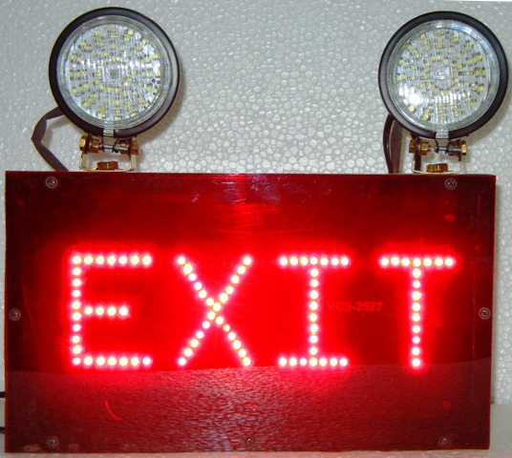
Specifications:-
This exit sign includes built in surge protection for spikes in voltage caused by lightening and static build up on components. This universal ... Commercial / Industrial Emergency Exit Lights & Emergency LED Exit Signs Promote Fire Safety ... This universal sign can be mounted on a ceiling or wall.

1. Long-life energy-saving LED technology.
2. Includes two LED 5-watt factory installed lamp
3. 12 -volt, 7Ah sealed lead acid, rechargeable, Maintenance-free battery provides 6 hour of emergency operation and Automatic timer option.
4. Automatic, low voltage disconnect (LVD)
5. Activates in event of partial power failure.
6. Available with industry-standard black housing.
7. EXIT LED available in two colors RED and GREEN.
8. INDUSTRIAL GRADE.

1. EMERGENCY LIGHT @ = RS. 4300.00
02 Nos. LED LIGHT WITH EXIT DOUBLE SIDE DISPLAY 3 Hr. BACKUP
2. EMERGENCY LIGHT @ = RS. 3950.00
02 Nos. LED LIGHT WITH EXIT SINGLE SIDE DISPLAY 5 Hr. BACKUP
3. EMERGENCY LIGHT @ = RS. 3500.00
02 Nos. LIGHT WITHOUT EXIT 7 Hr. BACKUP
4. EXIT LIGHT @ = RS. 3450.00
EXIT DOUBLE SIDE DISPLAY 12 Hr. BACKUP
5. EXIT LIGHT @ = RS. 2850.00
EXIT SINGLE SIDE DISPLAY 20 Hr. BACKUP
7 AH BATTERY & CHARGER

